|  |
| --- |
| CG GAMES |
| Assignment 3 – Haunted Clue House |
| **[ 3D First Person Game]** |
| Version #XX  All work Copyright © 2016 by CG Games.  All rights reserved. |
| **[Christopher Gelinas 300844877]** |
|  |



|  |
| --- |
| November 23, 2016 |

**Table of Contents**

**Contents**

Game Overview

Game Play Mechanics

Camera

Controls

Interface Sketch

Screen Descriptions

Game World

Characters

Enemies

Items/Collectibles

Scoring

Art / Multimedia Index

Future Features

# Game Overview

*Player assumes the role of a person inside a haunted house, the player must avoid a ghost which roams the house, while searching for clues to defeat it. The player wins if all clues are collected before the ghost catches them.*

# Game Play Mechanics

*Player sees the environment from a first person perspective, the player can move forward, backward, and jump using standard keyboard input, and look around with the mouse. The player should avoid being seen by the ghost, while moving about the house to find all clues.*

# Camera

*First person perspective*

# Controls

*Uses standard unity first person controller assets. The player uses the keyboard’s directional keys to move left, and right. The player can also jump with the space bar, and look around by moving the mouse.*

# Interface Sketch

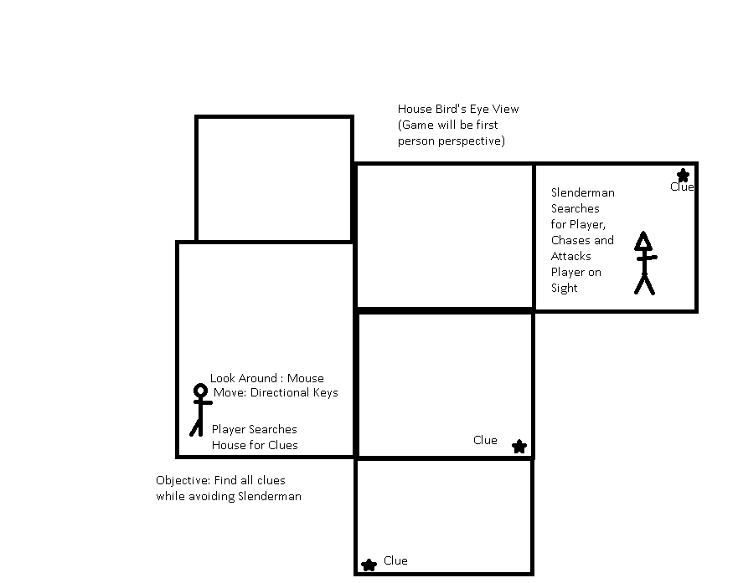

**(Original Concept: [SlenderMan Changed to Generic Ghost Character Since Original Idea])**

# Screen Descriptions

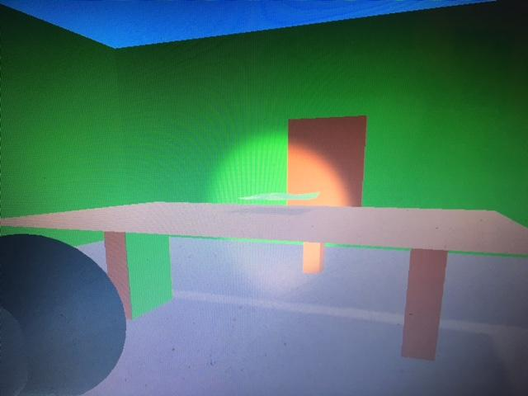

Player View at Game Start

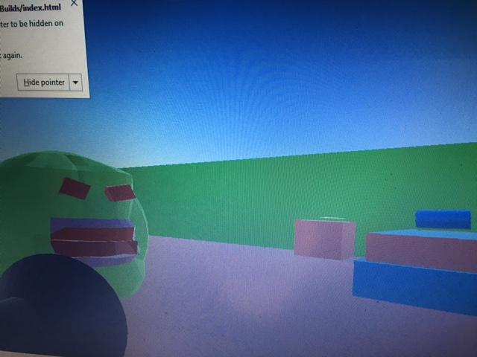

Gameplay Scene Running From Ghost

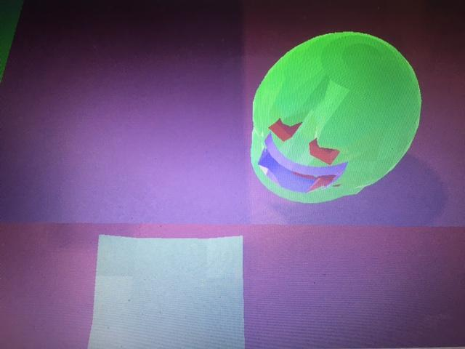

Collecting Final Item

# Game World

*3D environment seen from a first person perspective, the player is locked inside a haunted house.*

# Characters

*Protagonist – An unnamed protagonist who awakens to find themselves locked in a haunted house, they look around the house for clues while avoiding the roaming ghost.*

# Enemies

Ghost – An evil spirit which occupies the house where the player has been locked in. Walks around roaming the house and searching for the player character, if

# Items/Collectibles

Clues – Pieces of paper scattered about the house, when all of them are collected the player defeats the ghost and wins the game.

Flashlight – Adds a small light on the player camera to help find clues easier.

# Scoring

Score is increased every time the player collects a clue, game is won if all clues are collected before being caught by the ghost.

# Art / Multimedia Index

Kitchen

Living Room

Bedroom

Bar

Open Room

Storage Room

FlashLight

Enemy Ghost

(All models created by me using Blender, Blender files included in Github Repo)

# Future Features

Future versions of this game could include new features such as additional levels, with faster ghosts, and more clues for increased difficulty.